Practical 9 (Extra Question)

1. Create a Windows application that allows a user to input an account holder’s name and account number and create an Account object and then perform deposit and withdraw operations on the account object.

The Account class is as follows:

|  |
| --- |
| public class Account  {  private string name;  public string Name  { get { return name; } }  private string number;  public string Number  { get { return number; } }  private decimal balance;  public decimal Balance  { get { return balance; } }  public Account(string aName, string aNumber, decimal aBalance)  {  name = aName;  number = aNumber;  balance = aBalance;  }  public void Deposit(decimal amount)  {  balance += amount;  }  public void Withdraw(decimal amount)  {  balance -= amount;  }  } |

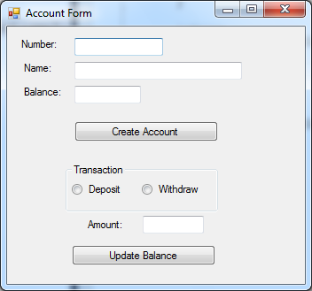

When application starts

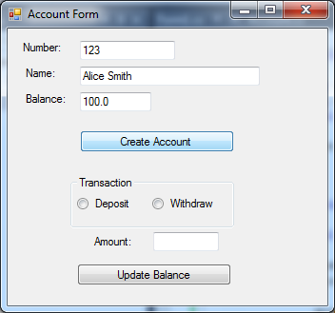

After user enters number, name, and balance, and clicks ‘Create Account’ button

After an Account object is created, the user can perform deposit and withdraw transactions.

The application will show the updated balance after each transaction.

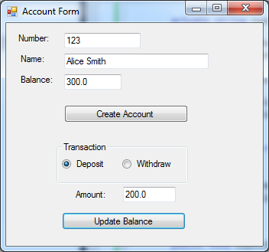

After user selects ‘Deposit’ radio button, enters an amount, anc clicks‘Update Balance’ button.

1. Modify the application in Question 6 to allow the user to create many Account objects and store in an ArrayList. Include a ‘Find Account’ button which finds an Account object based on the account number and displays the account details in the text boxes.

